**Fitness Tracker Data Analysis**

***Overview***

This project analyzes user activity data from a fitness tracker, focusing on steps, active minutes, and calories burned. The goal was to uncover behavioral patterns and generate health-related insights.

***Data Preparation***

The dataset was cleaned and formatted. The date column was converted for time series analysis. Missing or inconsistent values were handled.

***Exploratory Analysis***

Used pandas, matplotlib, and seaborn to explore distributions, outliers, and correlations. Identified trends in daily steps and visualized how calories burned relate to activity levels.

***Findings***

* Strong correlation between steps and calories.
* Users tend to be more active during weekdays.
* Sedentary vs. active users show clear differences in behavior.

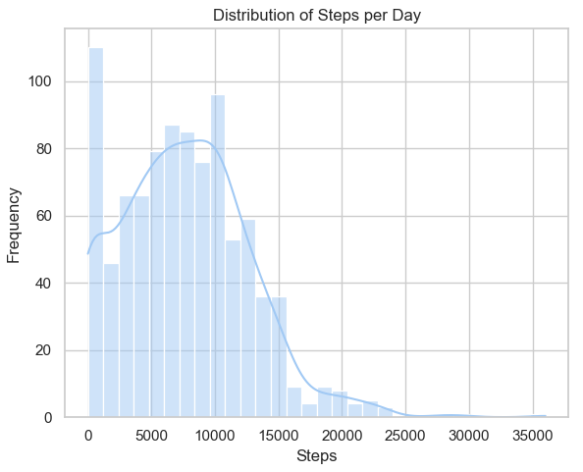

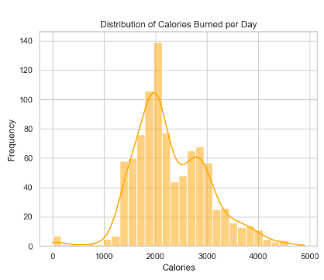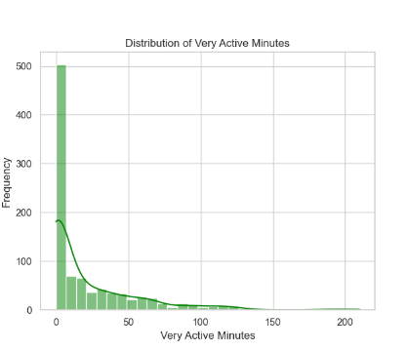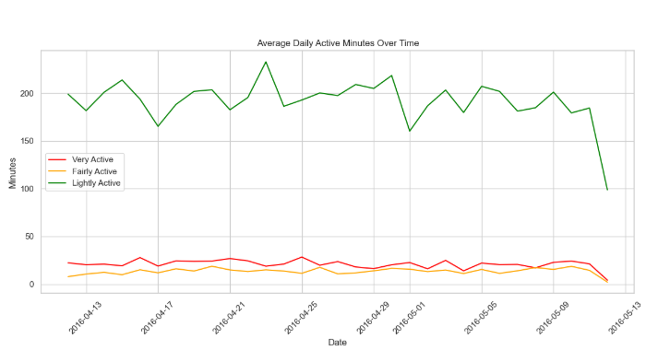

***Next Steps***

To extend the project, I would include user demographic data or apply clustering for deeper segmentation. The insights could be used for targeted fitness recommendations.

***Tools Used***

Python, pandas, matplotlib, seaborn, Jupyter Notebook.